Analyzing Leading Causes of Deaths in Illinois from 1990-2010
By: Tarak Pandya
Major Objective: The aim of this report is to answer specific questions related to Leading Causes of Death in state of Illinois from Year 1990-2010 based on variables of year, age group, type of deaths and major organs affected by using Data Visualization skills in R language.
Materials and Methods: Dataset was obtained from Illinois Center for Health Statistics, (https://data.illinois.gov/Health/Leading-Causes-of-Death-1990-2010/t224-vrp2/data). The data contains 2135 rows with 4 columns, Year, Age Group, Leading Causes of Death and Fatalities.
Software: R is used as the choice of language to generate the visualizations. Major questions that are answered in this study are: what are the top 5 leading causes of Deaths (with death counts) in Illinois from 1990-2010, what top 3 Years that most death occurred in, what age groups most deaths occurred and was there any trend or pattern associated with it, what major organ(s) was/were the cause of deaths and is there overall patterns seen among all variables throughout the 21 years period. Results: Based on the generated visualizations the top 5 leading causes of deaths (with death counts) in Illinois are Heart Disease, Diseases of Heart (these are different than Heart Disease), Malignant Neoplasms, Congenital anomalies and Cerebrovascular disease. Top 3 years that most death occurred were: 1999, 2000, and 2002 with in that major cause of Death was Heart Diseases. Among all age groups, ages 65 and older has highest mortality rate then ages 45-64 and ages 25-44. The obvious pattern was noted that higher the age groups there were more deaths occurred. Heart, Lungs, Brain and Congenital defects were major organ related deaths from 1990-2010. By referencing with Illinois Department of Public Health statistics, the findings matches with the published statistics from every ten years starting from 1990, 2000 and 2010. This confirmed that visualizations lead to correct conclusion. Overall, the heart diseases was among the top leading cause of death and over 21 years of period the numbers of deaths are declining throughout the years. For future study, using National Vital Statistics Report as a comparison, I could have used all 50 states mortality (leading cause of death) data and compare the causes among the states.

Introduction:
Ranking the leading causes of death is a popular method of presenting mortality statistics. Leading cause-of-death data have been published since 1952 and mortality data starting from 1949, when the official tabulations ranking leading causes of death were first introduced (1). Illinois state department of Public Health provides Open data (https://data.illinois.gov/Health/Leading-Causes-of-Death-1990-2010/t224-vrp2/data) on leading causes of death from 1990-2010. This democratic state is one of my favorite state because of Chicago Bulls and deep dish pizza and along with its medical coverage and accessibility of medical care. The leading causes of deaths are classified causes that were generated into lists which expanded and edited over time with revision of the International Classification of Diseases (ICD). Cause-of-death ranking is a useful tool for illustrating the relative burden of cause-specific mortality. However, it should be used with a clear understanding of what the rankings mean. Based on the visualization of data Image 1: Histogram of Top 5 Leading Causes of Deaths—including Malignant Neoplasms (Cancer), Heart Disease, Diseases of Heart, Cerebrovascular Disease and Congenital anomalies. From 1990-2010 data, malignant neoplasm and diseases of heart are among the leading causes of death in Illinois, shown in year 2011 with the most recent statistics. (http://www.idph.state.il.us/health/bdmd/leadingdeaths11.htm).

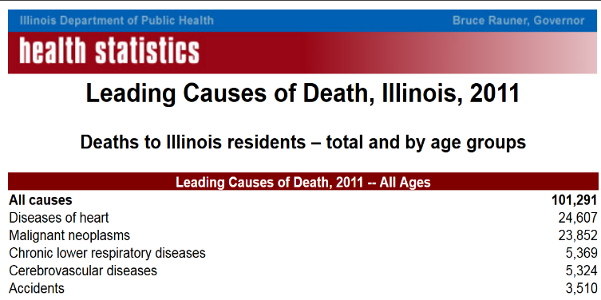
To compare most recent (year 2011) statistics with data from 1990-2010 years: Malignant Neoplasms are ranked 1st with little over one million deaths in 21 years combined (1,031,060 deaths exact), Diseases of Heart is 2nd with 681,970 deaths, Heart Disease as 3rd 622,314 deaths, Cerebrovascular disease as 4th 283,629 deaths and 5th as Congenital Anomalies with 175,421 death tolls. Note: These numbers are from the data 1990-2010 combined and if you were to compare the numbers from today it would only increases because as years passes the death tolls increases due to the population. To see recent stats on causes of death (2015) for all of the United States: (https://www.cdc.gov/injury/wisqars/leadingcauses.html )
For age group 65 and older, all of the leading causes of deaths are similar to years 1990-2010. This statistics from 2015 shows that all of the causes are the same but now Alzheimer’s disease has taken 5th ranked in death tolls. To find out about what top 3 years that had highest death counts look to the image on left: Years 1999, 2000 and 2002 show highest death 198,644 deaths, 194,676 deaths and 193,179 deaths, respectively. To see what trend the leading causes of deaths follows over 21 years, look on next page for leading causes of deaths with fatalities by years. You can see a clear top 5 leading causes of deaths numbers (counts) decreasing over period of time. This pattern is good indicator that more Illinois residents are taking appropriate precautions to take care of their heart.

The age group 65 and older, ages 45-64 and ages 25-44 has among the most death counts. Based on the data, type of affected organs are Heart, Lungs and Brain are among them cause the highest fatalities in 1990-2010. The facetted image below is of Type of affected organs with death counts by each year. This image shows you how many deaths occurred based on affected organs by year. Year 1999, 2000 and 2002 are top 3 years that cause of deaths, looking at these years you can see heart, lungs and brain are among the most common organs. This is not only true for only these three years but for all of those years from 1990-2010. So this indicate that most of the fatalities in Illinois occur due to or related to these organ conditions.

This image below indicates of what age groups has highest fatalities by organs. This show age 65 and older has highest death rate in all organs. Note: On x-axis, age groups and on y-axis are fatalities which is free of set continuous condition which show different numbers of y-axis.

Materials and Methods: Data set of Illinois Leading Causes of Death from 1990-2010 was taken from https://data.illinois.gov/Health/Leading-Causes-of-Death-1990-2010/t224-vrp2/data . R studio was used as software to perform data visualization. Particularly, ggplot (Grammar of Graphics) package was used to generate visualizations. The data set was subset using R’s tidyr and dplyr packages which are used for data manipulation. The data was also cleaned up in Excel for ease of use and duplicates were aggregated and misspelled categories were fixed. Majority of repeated categories were re-assigned to common names. For example, High Blood Pressure was changed to Hypertension. This was also done to save some space on graphs so names can fit with in axis. A new column with variable name “TYPE OF AFFECTED ORGAN” was created to provide with additional answers on what organs failures cause the highest deaths. I have assigned categories of organs based of the cause of death that occurred, e.g. assign Heart as category to cardiovascular disease, Lungs to Pulmonary Condition and so on. Improper symbols were taken out and file was save in csv format for analysis.

The image below, Leading Causes of death shows you that the heart, lungs, brain and congenital defects are among the most organ related deaths from 1990-2010.

Results: Overall, this paper helps answer some preliminary questions about dataset of Illinois State Leading Causes of Death from 1990-2010. This includes top 5 leading causes of deaths (with death counts) in Illinois are Heart Disease, Diseases of Heart (these are different than Heart Disease), Malignant Neoplasms, Congenital anomalies and Cerebrovascular disease. Top 3 years that most death occurred were: 1999, 2000, and 2002 with in that major cause of Death was Heart Diseases. Among all age groups, ages 65 and older has highest mortality rate then ages 45-64 and ages 25-44. The obvious pattern was noted that higher the age groups there were more deaths occurred. Heart, Lungs, Brain and Congenital defects were major organ related deaths from 1990-2010. By referencing with Illinois Department of Public Health statistics, the findings matches with the published statistics from every ten years starting from 1990, 2000 and 2010. This confirmed that visualizations lead to correct conclusion. Overall, the heart diseases was among the top leading cause of death and over 21 years of period the numbers of deaths are declining throughout the years. For future study, using National Vital Statistics Report as a comparison, I could have used all 50 states mortality (leading cause of death) data and compare the causes among the states.

Just a fact check on this using actual health statistics for every ten years, 1990, 2000 and 2010.
Illinois Public Health Statistics Comparison of 1990, 2000 and 2010—Top Leading Causes of Deaths (Except All Causes, which is total deaths number)
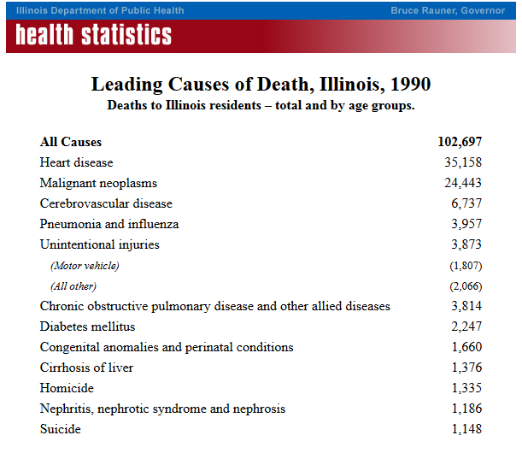
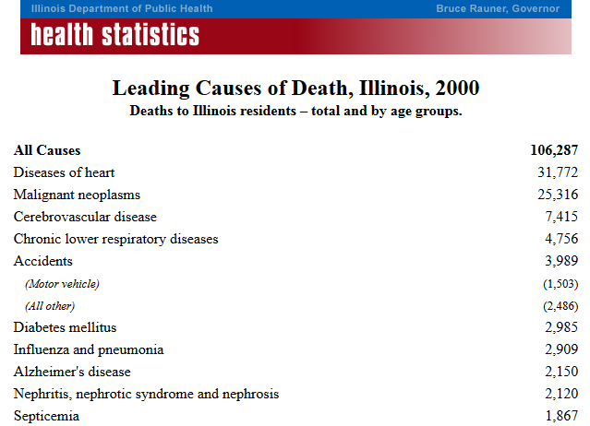
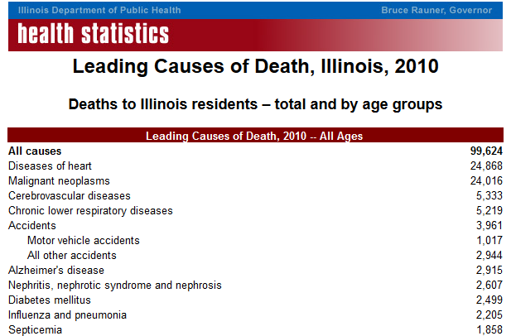
Similar of what we concluded from Data Visualization

References
- National Office of Vital Statistics. Leading causes of death: United States and each state, 1949. Vital statistics—Special reports, national summaries; volume 36 no 20.Washington, DC: Public Health Service. 1952.
- Illinois Department of Public Health (IDPH). Office of Policy, Planning, and Statistics, Illinois Center for Health Statistics: Leading Causes of Death, 1990-2010. Leading causes of death for Illinois residents was compiled by the IL Center for Health Statistics. (https://data.illinois.gov/Health/Leading-Causes-of-Death-1990-2010/t224-vrp2/data )
- Illinois Department of Public Health (IDPH) (http://www.idph.state.il.us/health/bdmd/leadingdeaths10.htm)
- Illinois Department of Public Health (IDPH) (http://www.idph.state.il.us/health/bdmd/leadingdeaths90.htm)
- Lake County, Illinois County office. (https://www.lakecountyil.gov/2698/Top-Causes-of-Death)
- Department of Public Health of Illinois. Top 10 causes of Death in Men (http://www.dph.illinois.gov/topics-services/life-stages-populations/mens-health/top-10-causes-death)
- Center for Disease Control (https://webappa.cdc.gov/sasweb/ncipc/leadcaus10_us.html)
- Center for Disease Control, Leading Causes of Death (https://www.cdc.gov/injury/wisqars/leadingcauses.html)

Final Project: Review:
- A write up in PDF or Doc format:
This document is the final project on Analyzing Leading Causes of Deaths in IL 1990-2010
- Explaining the data source and the process you took to arrive at your final result.
The data was taken from:
https://data.illinois.gov/Health/Leading-Causes-of-Death-1990-2010/t224-vrp2/data
The data contains 2135 rows with 4 columns, Year, Age Group, Leading Causes of Death and Fatalities. Appropriate data massaging techniques were done to make ready for data visualization. Using application R Studio—More Information on how to download R and R Studio below.
- Describing how your visualization(s) adhere to the various principles discussed in the selected readings:
I have analyze my graphs using Tufte’s and Kosslyn’s Principles and Cairo’s wheel of Visualization. (https://moz.com/blog/data-visualization-principles-lessons-from-tufte )
- Show the data: I have shown the data visually, 2) Provoke thought and share: This visualizations I made were based of reading health statistics and Reports of how to take best approach for my data that it shows the information best way possible. 3) Avoid Distortion and 4) provide much information in small space: I have generated maps that provides 21 years of information with 9 variables in less than one page of facetted maps. 5) This also supports making large dataset coherent and encourage eyes to compare data. 6) Also, reveal data in a several levels of detail by using multi-facet form to show the data in R. 7) each map with a clear purpose in mind. I can say that all of the graphs avoids chart-junk and clutter, but I created some graphs with too much detail in one which puts pressure on the viewer to absorb excessive information.
Any closing thoughts on what you found and where you would go next if given more time.
For the next time, I would like to ask with county specific data and find out what are leading causes of deaths in specific counties. Also apply some statistical tests that answers specific questions on what percentages of population are dying from specific cause and what precautions can be taken to avoid the higher death tolls.
All materials required for me to recreate the visualization:
R Code is provided to generate the similar visualization on your machine.
NOTE: do not install R studio First, install R Language itself first.
Step 1: Go to this site: https://cran.r-project.org/ , Click on Download R for Mac OS X for you.
Then Click on **R-3.4.0 pkg** this downloads binary for OS X 10.11 (El Capitan) and higher, signed package.
Step 2: Follow Installation guide and install R Language on your machine.
Step 3: Go to https://www.rstudio.com/products/rstudio/download/ and Click on
RStudio 1.0.143 - Mac OS X 10.6+ (64-bit) | 71.2 MB | 2017-04-19 | c7f1ed865428b225b202fd1b431954b4
Step 4: Follow guidelines to properly install R Studio in your machine
If extra software is required, a brief procedure on how to get running is appreciated
Yep! Above are the steps of how to get started with R studio and making those great visualizations.
Depending on your project there may be some variance - contact me on the blackboard discussion board if you have any specific questions relating to your deliverables.

